**K226007**

**Lab 11**

**BCS-5L**

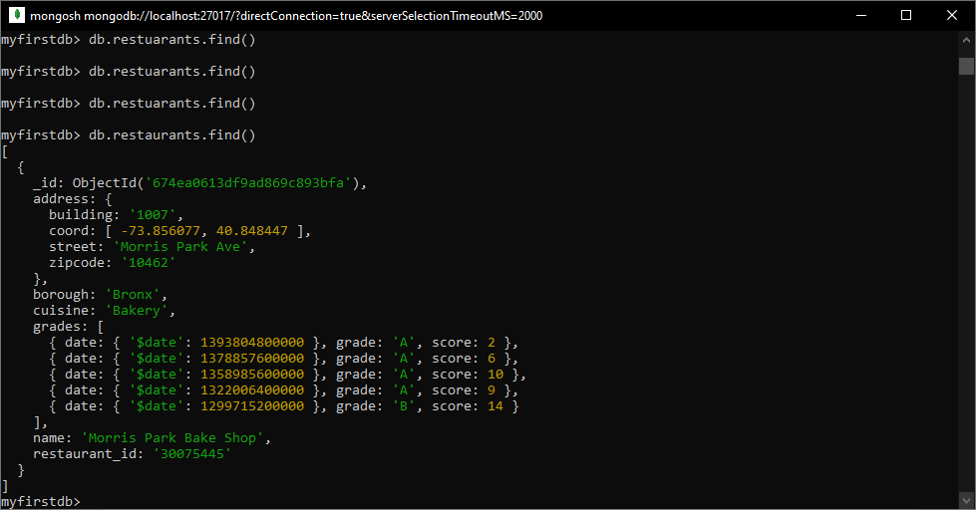

db.restaurants.find()

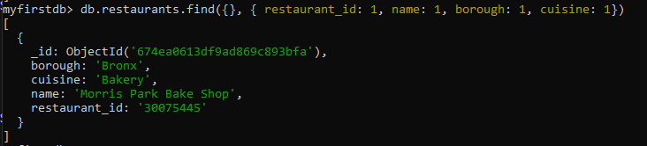

db.restaurants.find({}, { restaurant_id: 1, name: 1, borough: 1, cuisine: 1})

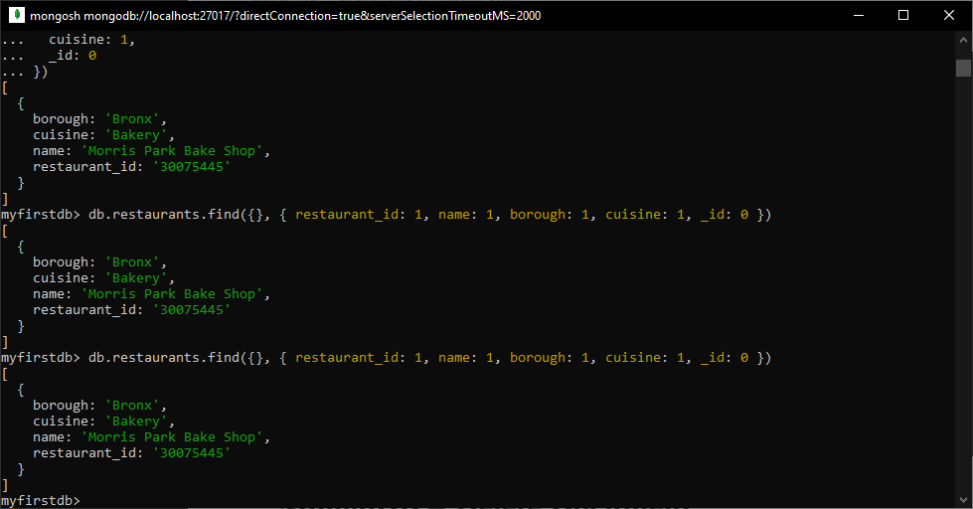

db.restaurants.find({}, { restaurant_id: 1, name: 1, borough: 1, cuisine: 1, _id: 0 })

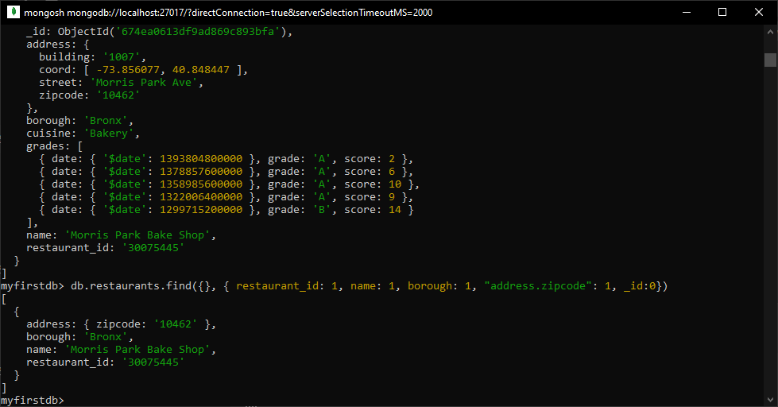

db.restaurants.find({}, { restaurant_id: 1, name: 1, borough: 1, "address.zipcode": 1, _id:0})

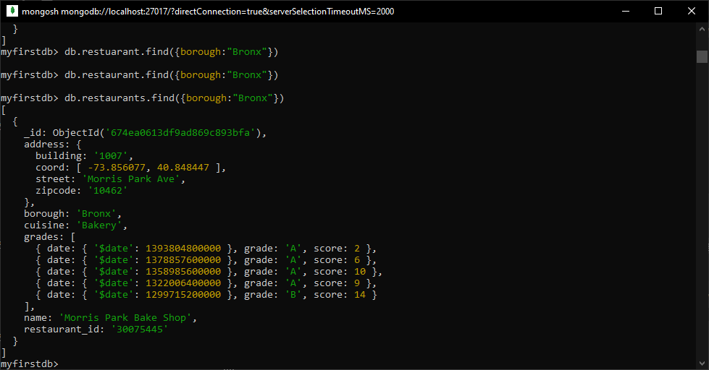

db.restaurants.find({borough:"Bronx"})

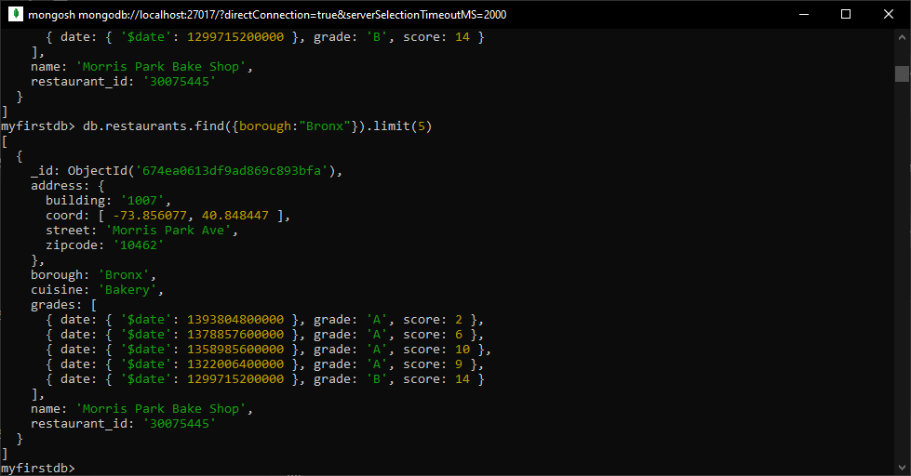

db.restaurants.find({borough:"Bronx"}).limit(5)

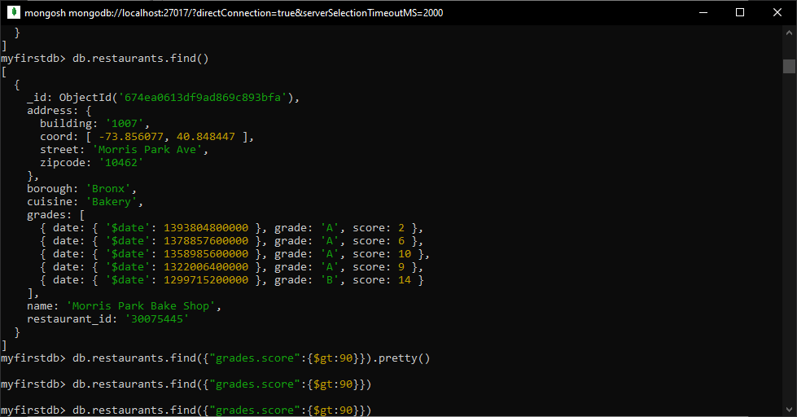

db.restaurants.find({"grades.score":{$gt:90}})

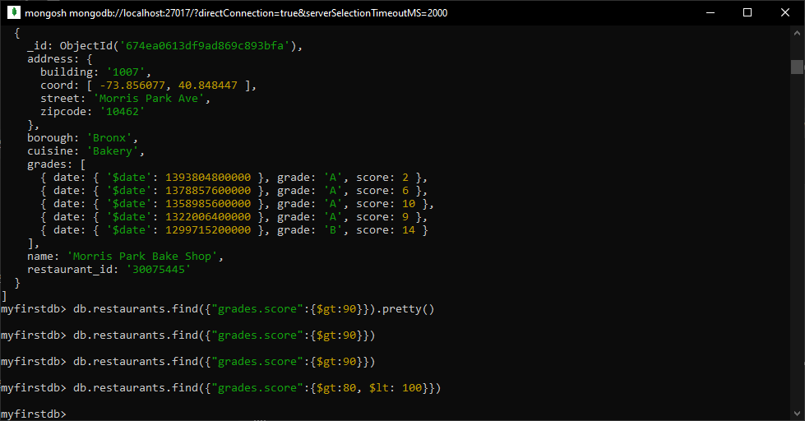

db.restaurants.find({"grades.score":{$gt:80, $lt: 100}})

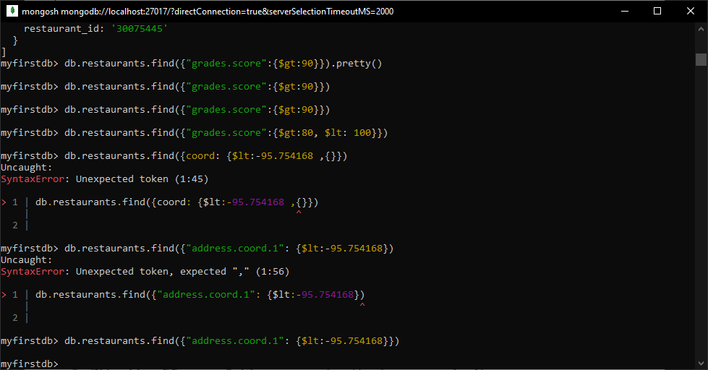

db.restaurants.find({"address.coord.1": {$lt:-95.754168}})

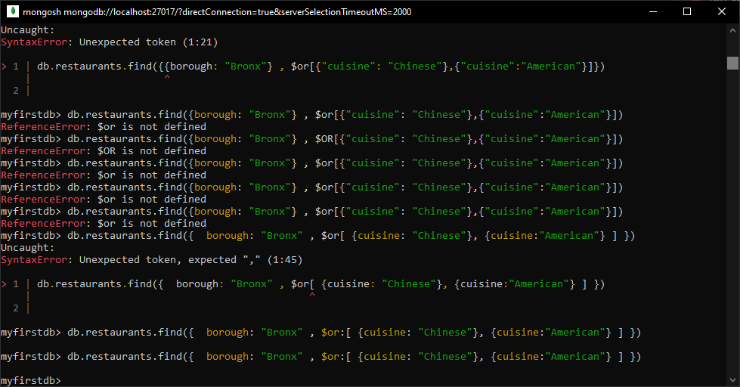

db.restaurants.find({ borough: "Bronx" , $or:[ {cuisine: "Chinese"}, {cuisine:"American"} ] })